Neural network for the following neuron

For the expression y=0.3x+2

This expression acts as a line in a 2-dimensional graph, all the points above the line is treated as class ‘0’ and all the points that lie below the line is treated as class ‘1’.

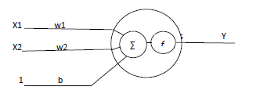

X1 X2 Y

1 2.2 0

1 2.4 1

… … …